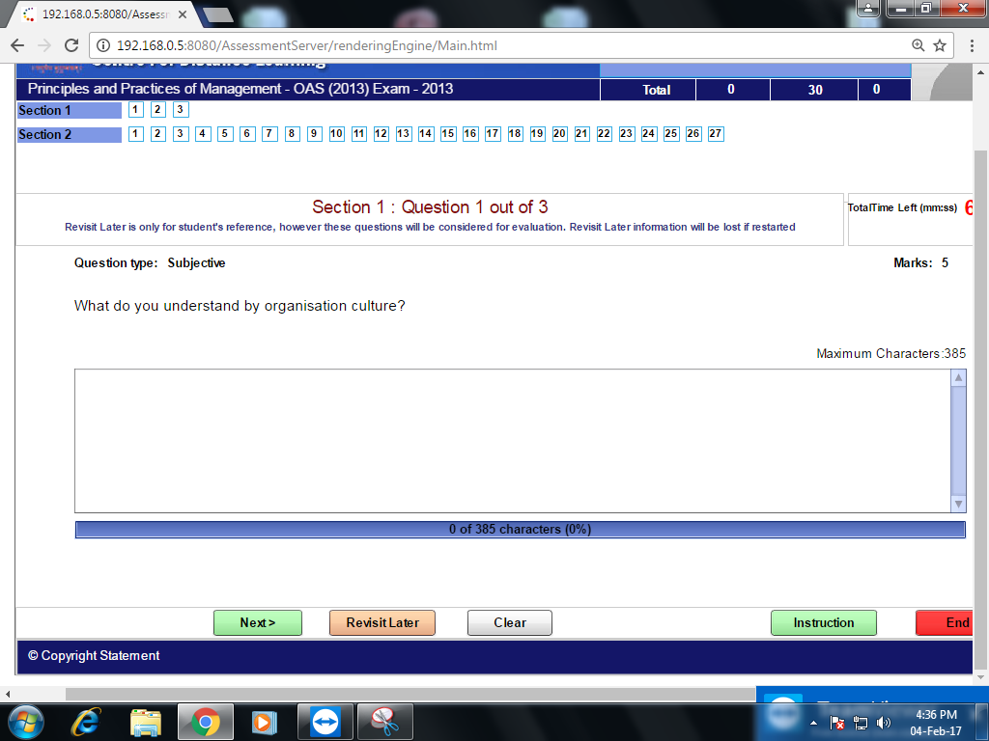
Organizational culture is the collection of values, expectations, and practices that guide and inform the actions of all team members. Think of it as the collection of traits that make your company what it is.
Culture is created through consistent and authentic behaviors, not press releases or policy documents.
An organization's culture defines the proper way to behave within the organization. This culture consists of shared beliefs and values established by leaders
MATCH THE FOLLOWING:-
An employee permits to participate in organization structure Participative organization
External changes in business environment Management of change
Negatives forces of employees in changing environment Resistance of change
Changes in organization structure Flexible Org. structure
MATCH THE FOLLOWING:-
Big dis-advantage of this type of decision system is Group decisions nobody takes his responsibility
Targets are decided in terms of quantity Quantitative decisions
Air thematic term need to show conversion of Impute qualitative decisions into quantitative decisions
Decisions taken to improve quality Qualitative decisions
